Task4
#include <stdio.h>
#include <string.h>
#include <arpa/inet.h>

typedef unsigned char u_char;

int dissect_ipv4(const u_char *ip)
{
int version = ip[0] >> 4;
int ihl = ip[0] & 0x0F;
int hdr_len = ihl * 4;

unsigned short total_len = ntohs(*(const unsigned short *)(ip + 2));

unsigned short id = ntohs(*(const unsigned short *)(ip + 4));

unsigned short ff = ntohs(*(const unsigned short *)(ip + 6));
int df = (ff & 0x4000) != 0;
int mf = (ff & 0x2000) != 0;
int frag_offset = ff & 0x1FFF;

int ttl = ip[8];
int proto = ip[9];

unsigned short checksum = ntohs(*(const unsigned short *)(ip + 10));

char src[16], dst[16];
snprintf(src, sizeof src, "%d.%d.%d.%d", ip[12], ip[13], ip[14], ip[15]);
snprintf(dst, sizeof dst, "%d.%d.%d.%d", ip[16], ip[17], ip[18], ip[19]);

printf(" --- IPv4 Header ---\n");
printf(" Version : %d\n", version);
printf(" IHL : %d words (%d bytes)\n", ihl, hdr_len);
printf(" Total Length : %u bytes\n", total_len);
printf(" Identification : 0x%04X\n", id);
printf(" Flags : DF=%s, MF=%s\n", df ? "set" : "not set", mf ? "set" : "not set");
printf(" Fragment Offset: %d (byte offset %d)\n", frag_offset, frag_offset * 8);
printf(" TTL : %d\n", ttl);
printf(" Protocol : %d (%s)\n", proto,
proto == 6 ? "TCP" : proto == 17 ? "UDP" : "Other");
printf(" Checksum : 0x%04X\n", checksum);
printf(" Source IP : %s\n", src);
printf(" Destination IP : %s\n", dst);

return hdr_len;
}

int main(void)
{
u_char frame[] = {
0x00,0x1A,0x2B,0x3C,0x4D,0x5E,0x08,0x00,0x27,0xAA,0xBB,0xCC,0x08,0x00,
0x45,0x00,0x00,0x28,0x1C,0x46,0x40,0x00,0x40,0x06,0x26,0xFD,
0xC0,0xA8,0x01,0x0A,0x5D,0xB8,0xD8,0x22,
0xC3,0x50,0x00,0x50,0x00,0x00,0x03,0xE8,0x00,0x00,0x00,0x00,
0x50,0x02,0x72,0x10,0x1A,0x2B,0x00,0x00
};
dissect_ipv4(frame + 14);
return 0;
}

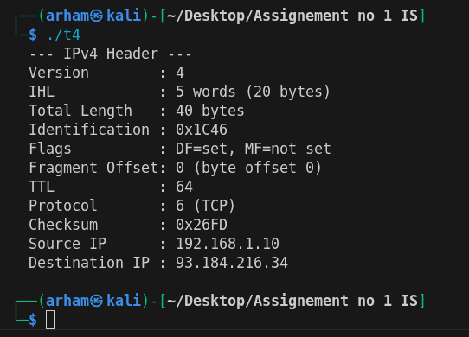
Task5

#include <stdio.h>
#include <string.h>
#include <arpa/inet.h>

typedef unsigned char u_char;

const char *port_to_app(int port)
{
switch (port) {
case 80: return "HTTP (web)";
case 25: return "SMTP (email)";
case 20:
case 21: return "FTP";
case 53: return "DNS";
case 443: return "HTTPS";
case 22: return "SSH";
case 23: return "Telnet";
default: return NULL;
}
}

static void print_app(int sport, int dport)
{
const char *a = port_to_app(dport);
if (!a) a = port_to_app(sport);
printf(" Application : %s\n", a ? a : "Unknown");
}

void dissect_transport(const u_char *packet, int ip_hdr_len, int proto)
{
const u_char *t = packet + 14 + ip_hdr_len;

int sport = (t[0] << 8) | t[1];
int dport = (t[2] << 8) | t[3];

if (proto == 6) {
unsigned int seq = ((unsigned)t[4] << 24) | (t[5] << 16) | (t[6] << 8) | t[7];
unsigned int ack = ((unsigned)t[8] << 24) | (t[9] << 16) | (t[10] << 8) | t[11];

int words = t[12] >> 4;

int f = t[13];

printf(" --- TCP Header ---\n");
printf(" Source Port : %d\n", sport);
printf(" Dest Port : %d\n", dport);
printf(" Sequence No. : %u\n", seq);
printf(" Ack No. : %u\n", ack);
printf(" Header Length : %d words (%d bytes)\n", words, words * 4);
printf(" Flags :");
if (f & 0x20) printf(" URG");
if (f & 0x10) printf(" ACK");
if (f & 0x08) printf(" PSH");
if (f & 0x04) printf(" RST");
if (f & 0x02) printf(" SYN");
if (f & 0x01) printf(" FIN");
printf("\n");
print_app(sport, dport);
}
else if (proto == 17) {
int len = (t[4] << 8) | t[5];
int chk = (t[6] << 8) | t[7];

printf(" --- UDP Header ---\n");
printf(" Source Port : %d\n", sport);
printf(" Dest Port : %d\n", dport);
printf(" Length : %d bytes\n", len);
printf(" Checksum : 0x%04X\n", chk);
print_app(sport, dport);
}
}

int main(void)
{
u_char tcp_frame[] = {
0x00,0x1A,0x2B,0x3C,0x4D,0x5E,0x08,0x00,0x27,0xAA,0xBB,0xCC,0x08,0x00,
0x45,0x00,0x00,0x28,0x1C,0x46,0x40,0x00,0x40,0x06,0x26,0xFD,
0xC0,0xA8,0x01,0x0A,0x5D,0xB8,0xD8,0x22,
0xC3,0x50,0x00,0x50,0x00,0x00,0x03,0xE8,0x00,0x00,0x00,0x00,
0x50,0x02,0x72,0x10,0x1A,0x2B,0x00,0x00
};
printf("TCP test (Task 6 frame):\n");
dissect_transport(tcp_frame, 20, 6);

u_char udp_frame[14 + 20 + 8] = {0};
udp_frame[14] = 0x45; udp_frame[14 + 9] = 17;
u_char *u = udp_frame + 34;
u[0] = 0xD4; u[1] = 0x31;
u[2] = 0x00; u[3] = 0x35;
u[4] = 0x00; u[5] = 0x20;
u[6] = 0x12; u[7] = 0x34;
printf("\nUDP test (DNS):\n");
dissect_transport(udp_frame, 20, 17);
return 0;
}

